UML by example
UML, short for Unified Modelling Language, comprises a collection of diagrams used for constructing, modelling, and documenting software systems through graphical representation. It empowers developers to plan before writing code by offering a standardised set of notation tools applicable to any object-oriented project.
By presenting others with a graphical diagram of your design, you provide fellow developers with a clear view of your project and the positioning and usage of different artifacts, such as classes. Ultimately, interpreting a diagram is much simpler than reading thousands of lines of code!
In this short tutorial, you will learn how to construct a UML Class diagram by example.
Class diagram are a static structure diagram that describes the blueprint of your system.
A well-designed class diagram makes coding easier and improves maintenance in the later stages.
How to draw a Class in a Class diagram?
The following diagram shows how to show fields, a constructor, and methods in a class.
Please note, public members names are declared with a + and private members with a -

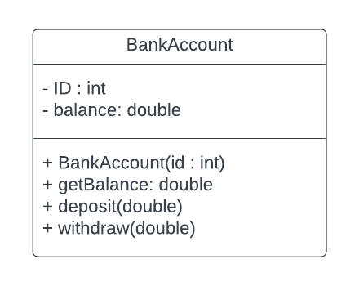 | public class BankAccount {  private int id;  private double balance;  public BankAccount(int id) {  this.id = id;  }  public double getBalance() {  return balance;  }  public void deposit(double money) {  balance += money;  }  public void withdraw(double money) {  balance -= money;  }  }

Specify association between classes
The association between one class and another is shown as an arrow.
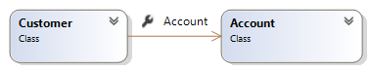 | class Customer {  Account account;  public Customer() {  account = new Account();  }  }

Show dependency between classes (loose association)
In the example below, the Bank class only uses the Account object briefly.
Please note the dotted arrow.
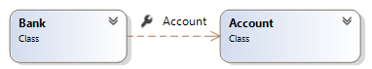 | class Bank {  public register(Account acc) {  // code to register the account  }

Another example:
class Bank {
public void register(int id) {
Account account = new Account(id);
// code to register account
}
}

Inheritance – Extending Classes
UML symbol for inheritance (extending a super/base class) is an arrow with a hollow triangle.
You can use this notation to extend a concrete or an abstract class.
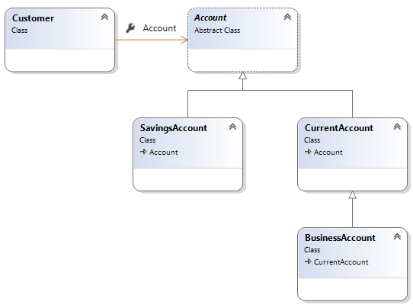
In the above diagram, the Account class is an Abstract Class. SavingsAccount and CurrentAccount extends (sub-class / derived from) the Account Class.
As you can see, the BusinessAccount inherit from the CurrentAccount Class.
Therefore, BusinessAccount is a kind of CurrentAccount and is also a kind of Account Class.
The above design offers great flexibility in writing code (see below).
The Customer Class has a reference of type Account which can then be set to any type of Account.
You can add new accounts in future and your code will cope.
class Customer {
Account account;
public void openAccount(int id) {
account = new SavingsAccount(123);
// or
account = new CurrentAccount(123);
// or
account = new BusinessAccount(123);

}
}

Interfaces and UML
UML notation for specifying an interface is a dotted arrow. The Interface is also marked with the word <<interface>> as seen bellow. Here the SavingsAccount, Implements the Taxable interface.
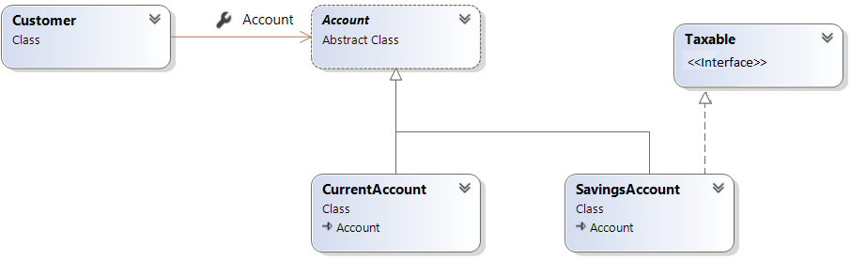

Multiplicty

(For simplicity we will avoid the discussion of Composition and Aggregation and their UML notation)
Multiplicity in associations is shown with numbers and * as shown in the example below.
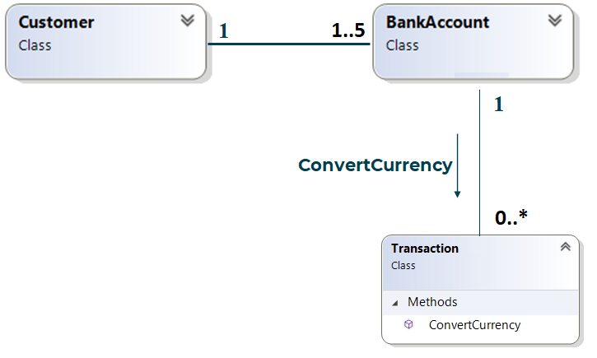
Each customer must have at least 1 Bank Account.
A customer can have up to 5 accounts.
An account is associated with only 1 Customer (in this case no joint account is allowed).
Each account is associated with zero to many Transaction objects (can also be shown with a single *)

